**Project: Airbnb Dynamic Pricing Recommendation Engine**

**(Sr.No 9 in the list of projects) Name: Samala Sudhakar;**

**Github:**

**Introduction:**

Analyzing historical Airbnb data to suggest optimal pricing based on location, season, and listing quality.

**Abstract:**

* This project presents a dynamic pricing recommendation engine designed to optimize Airbnb listing prices based on key variables including location and listing quality. Utilizing historical Airbnb data, the engine employs data preprocessing, feature engineering, and machine learning models to uncover pricing trends and correlations.

**Objectives:**

* Analyzing pricing by city, property type, reviews.
* Running regression model to find pricing predictors using machine learning.
* Creating dashboard with price suggestion slider using Tableau.

**Tools Used:**

* Python with its libraries like Pandas,numpy,Seaborn,xgboost,sklearn,Tensorflow,joblibs.
* Tableau for interactive dashboard and visualizations.

**Steps Involved in Building the Project:**

1.Made virtual environment

2.Installed the required packages

3.Importing the dataset into pandas

4.EDA:

a) Checking for null values

b) Removing or dropping null values

c) Removing outliers from log_price (Target variable)

d) Dropping the columns which are not required.

e) Checking the correlation of log_price with other dependable variables

There is a better relationship between log_price with

**room_type               0.652710**

**accommodates            0.553487**

**beds                    0.438267**

**bedrooms                0.434798**

**bathrooms               0.238699**

**SF                      0.185518**

**cleaning_fee            0.167707**

**review_scores_rating    0.071382**

f) Replace the categorical variables with numerical values : columns like:

cancellation_policy, property_type, instant_bookable , cleaning_fee,

city (Using oneHot Encoding) and room_type.

5. Tried different ML models for model building:

Rank Model R2 Score

1 Random Forest 0.578084

0 Linear Regression 0.578555

2 XGBoost 0.621328

**XGBoost (XGBRegressor) model has given more accuracy/R2 score (0.62). Model was saved.**

6. **Made Deep Neural Network (DNN) model also using Tensorflow library. Model was saved, but the accuracy was low. Then chose XGBRegressor for price prediction.**

**Tableau for Data Visualization and Dashboard**

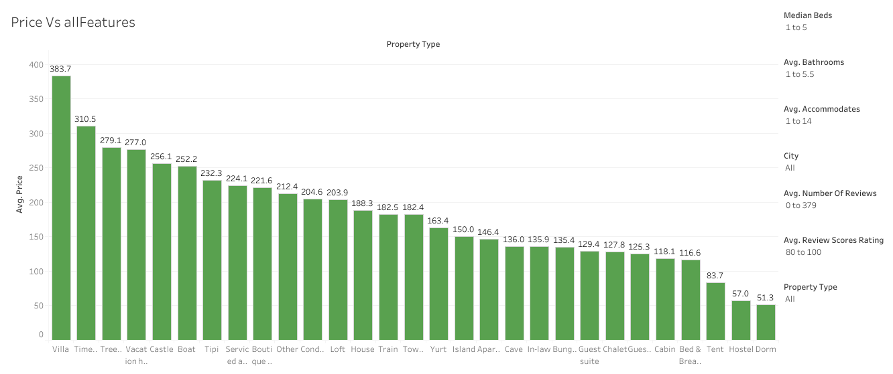

[**https://public.tableau.com/app/profile/sudhakar.s5439/viz/AirBNB_Price_Analysis/Dashboard1?publish=yes**](https://public.tableau.com/app/profile/sudhakar.s5439/viz/AirBNB_Price_Analysis/Dashboard1?publish=yes)

**City Vs Price:** [**https://public.tableau.com/app/profile/sudhakar.s5439/viz/AirBNB_Price_Analysis/CityVsPrice?publish=yes**](https://public.tableau.com/app/profile/sudhakar.s5439/viz/AirBNB_Price_Analysis/CityVsPrice?publish=yes)

**Property Vs Price**

[**https://public.tableau.com/app/profile/sudhakar.s5439/viz/AirBNB_Price_Analysis/PropertyTypeVsPrice?publish=yes**](https://public.tableau.com/app/profile/sudhakar.s5439/viz/AirBNB_Price_Analysis/PropertyTypeVsPrice?publish=yes)

**Conclusion:**

**Summary: Average Price**

1. **Boston: Maximum: 358 $ for Boat and Minimum: 65 $ for Dorm.**
2. **Chicago: Maximum: 389 $ for Vacation Home and Minimum: 33 $ for Villa.**
3. **DC: Maximum: 303 $ for Loft and Minimum: 25 $ for Treehouse.**
4. **LA: Maximum: 424 $ for Villa and Minimum: 42 $ for Dorm.**
5. **NYC: Maximum: 347 $ for Boutique Hotel and Minimum: 73 $ for Dorm.**
6. **SF: Maximum: 1200 $ for Served Apartment and Minimum: 84 $ for Dorm.**